1. 
2. In this course, we will see how to do testing for Spring Boot
   1. Junit
   2. Integration.
3. 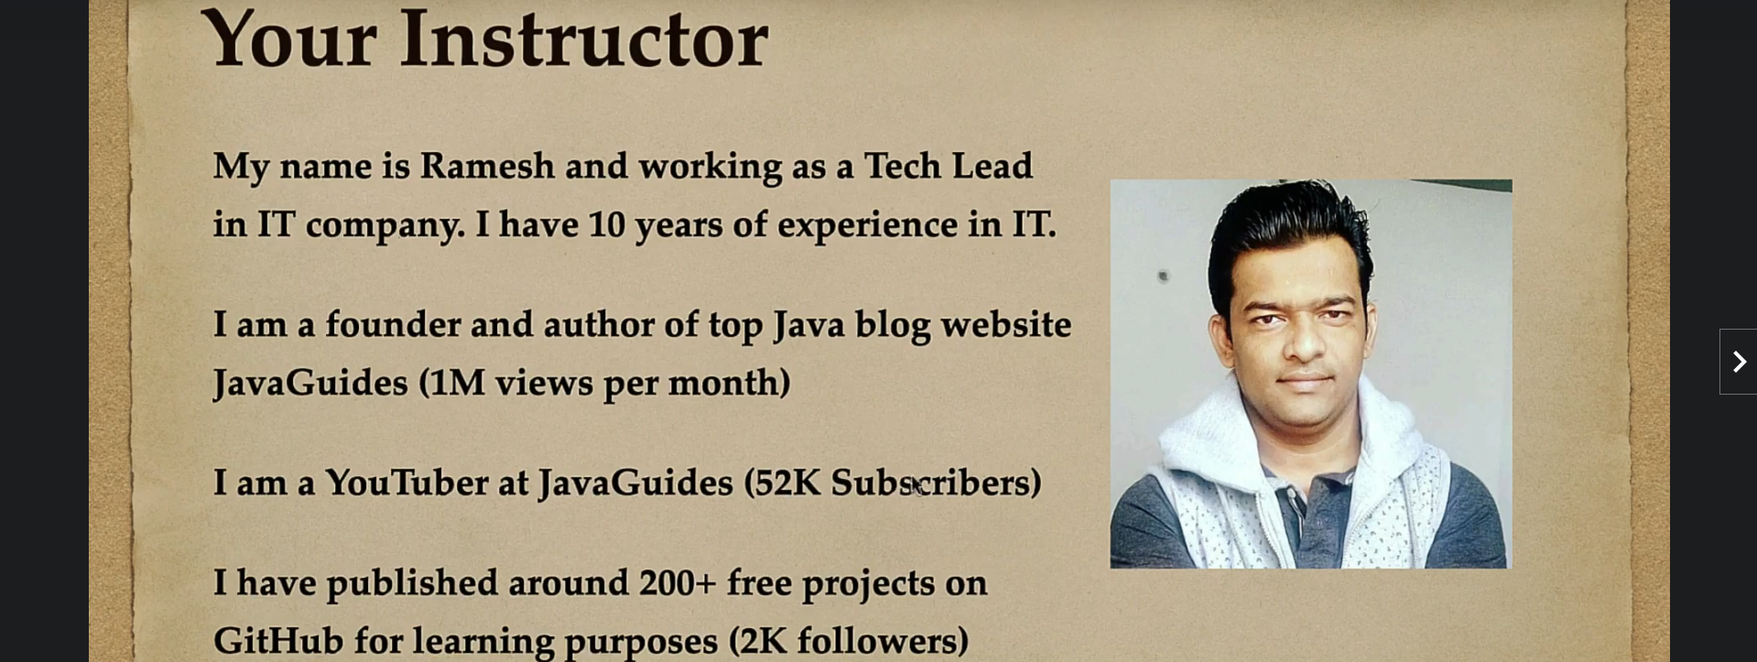
4. What we will learn in this course:
5. **Spring Boot Unit Testing**:  
   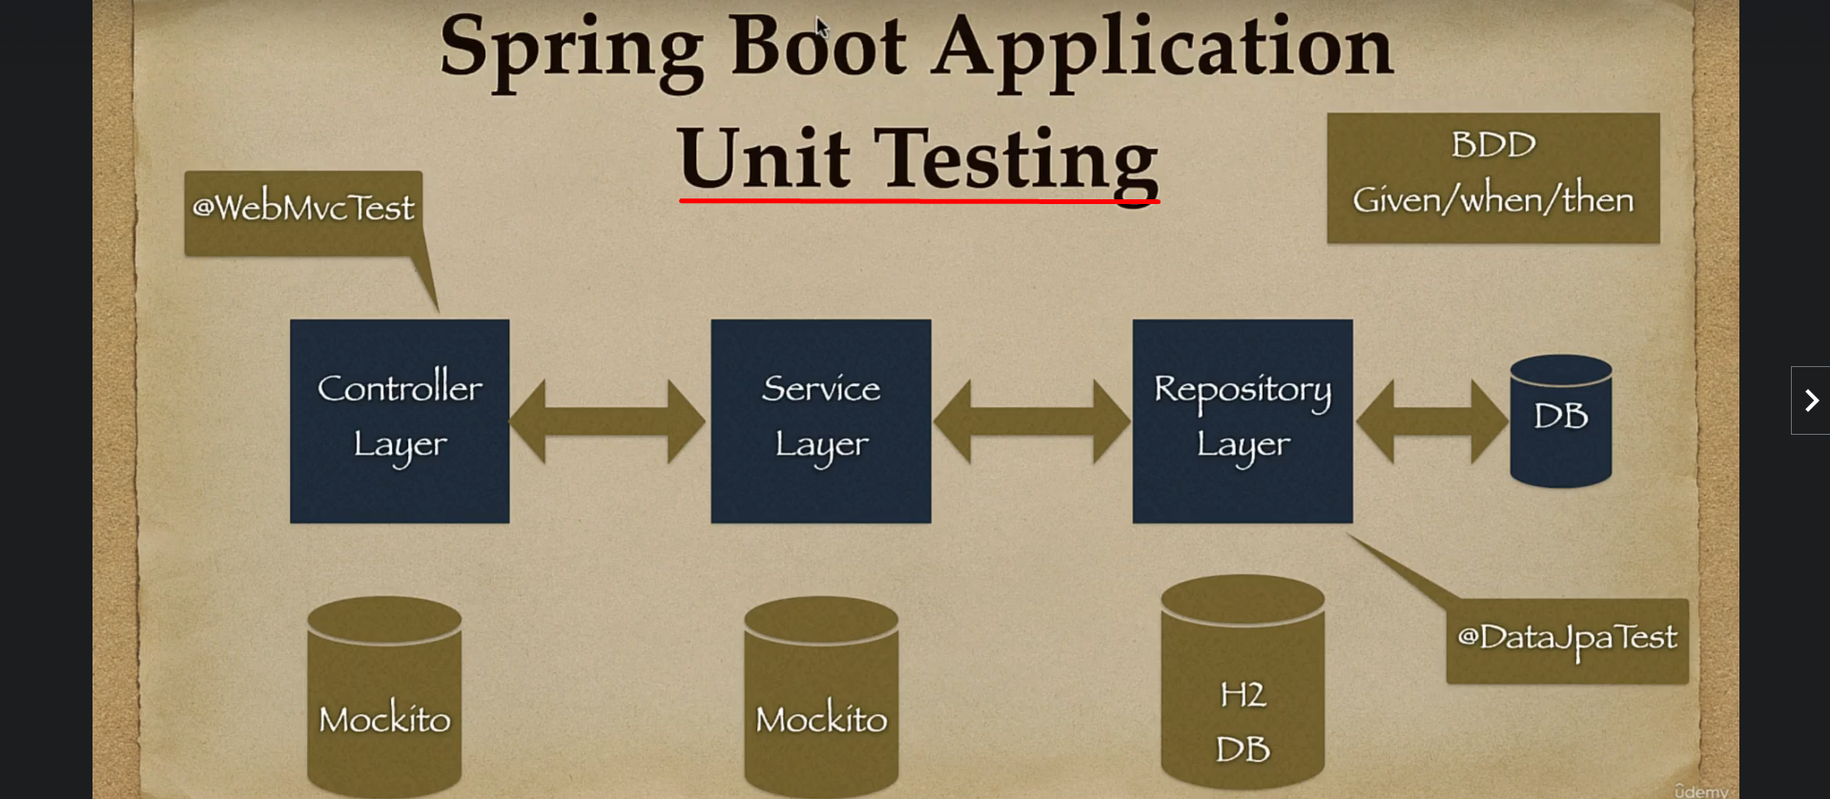
   1. There are 3-layers in the Spring Boot Application.
   2. We will see how to unit test each layer.
   3. We will follow BDD (**B**ehaviour **D**riven **A**rchitecture) style to write unit as well as integration test cases.
   4. 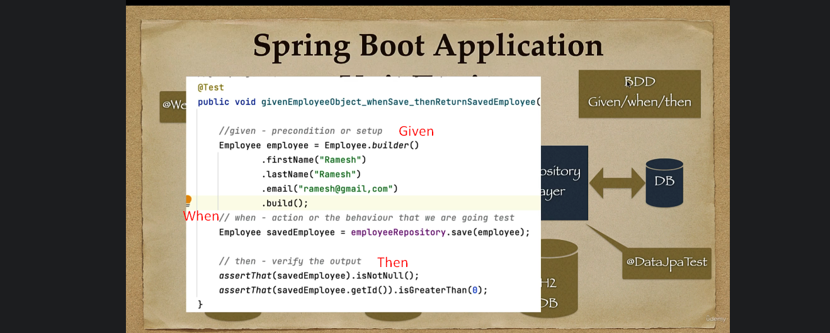
6. **Spring Boot Integration Testing**:  
   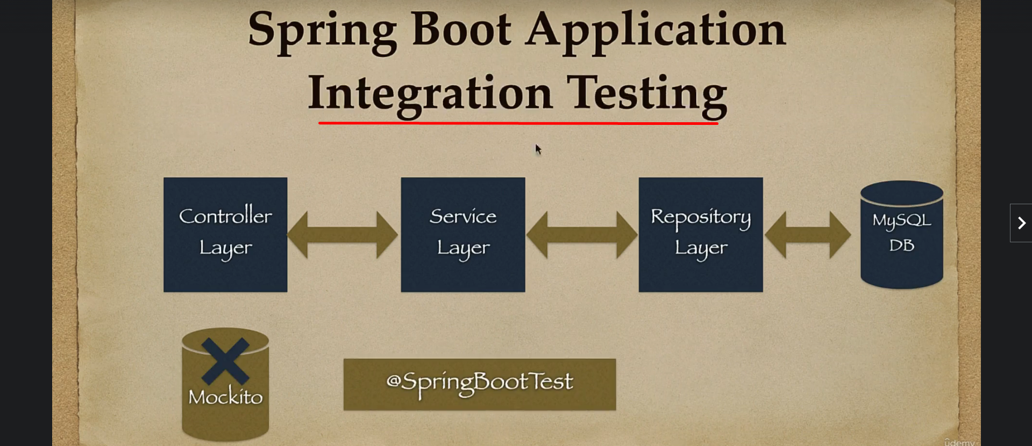
7. 
8. We will start with **unit testing Repository layer**.  
   We will see how to unit test
   1. CRUD Methods.
   2. Native Queries.
   3. JPQL Queries.
   4. Custom Queries.
9. We are going to use **@DataJpaTest** annotation for unit testing repository components as this annotation **automatically configure in-memory DB for testing purpose**. We are going to use in-memory database to store and retrieve data.  
   We don’t need to use Mockito while unit testing Repository Components.
10. Then afterwards, we will move to unit testing Service Layer Components.  
    As service layer is dependent on Repository layer so we need to mock repository layer component for service layer for which we will use mockito framework.  
    We will see how to use mockito framework to mock objects and how to stub their methods.
11. **Controller Layer**:
    1. We will use **@WebMvcTest** annotation to unit test Controller layer.
    2. We will unit test REST APIs 🡪 GET, PUT, POST.
    3. We will use Mockito framework to mock service layer components as controller layer depends on service layer.
12. Layer on, we will learn how to do integration testing for Spring Boot application.
13. 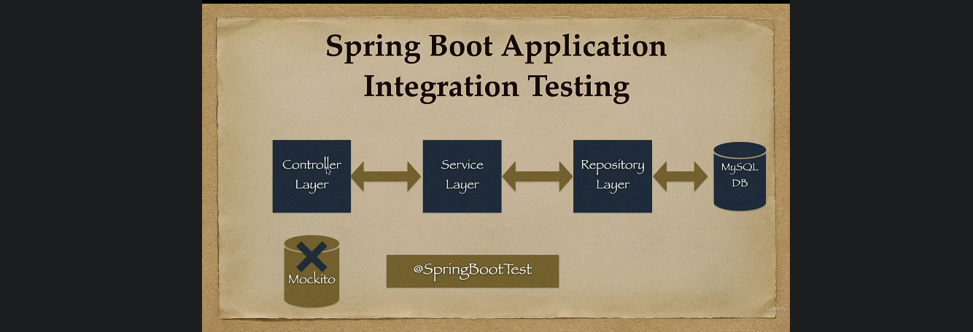
14. 
15. 